Care Coordination

Decision Support Tool (DST)

Software Version 1.0.09

Deployment, Installation, Back-Out, and Rollback Guide (DIBR)



July 2019

Department of Veterans Affairs

Office of Information and Technology (OIT)

Revision History

|  |  |  |  |
| --- | --- | --- | --- |
| Date | Version | Description | Author |
| 07/16/2019 | 0.8 | Updated for v1.0.09 | AbleVets LLC |
| 07/08/2019 | 0.7 | Updated for v1.0.08 | AbleVets LLC |
| 06/12/2019 | 0.6 | Updated for v1.0.05 | AbleVets LLC |
| 05/30/2019 | 0.5 | Updated for v1.0.04 | AbleVets LLC |
| 05/15/2019 | 0.4 | Defect remediation | AbleVets LLC |
| 04/26/2019 | 0.3 | Defect remediation | AbleVets LLC |
| 04/24/2019 | 0.2 | Added TLS installation specific to  GMRC*3.0*125 Patch Information | AbleVets LLC |
| 04/11/2019 | 0.1 | Initial Draft | AbleVets LLC |

Artifact Rationale

This document describes the Deployment, Installation, Back-out, and Rollback Plan for new products going into the VA Enterprise. The plan includes information about system support, issue tracking, escalation processes, and roles and responsibilities involved in all those activities. Its purpose is to provide clients, stakeholders, and support personnel with a smooth transition to the new product or software, and should be structured appropriately, to reflect particulars of these procedures at a single or at multiple locations.

Per the Veteran-focused Integrated Process (VIP) Guide, the Deployment, Installation, Back-out, and Rollback Plan is required to be completed prior to Critical Decision Point #2 (CD #2), with the expectation that it will be updated throughout the lifecycle of the project for each build, as needed.

Table of Contents

1. Introduction 1

1.1 Purpose 1

1.2 Dependencies 1

1.3 Constraints 2

2. Roles and Responsibilities 3

3. Deployment 3

3.1 Timeline 4

3.2 Site Readiness Assessment 4

3.2.1 Deployment Topology (Targeted Architecture) 5

3.2.2 Site Information (Locations, Deployment Recipients) 5

3.3 Resources 5

3.3.1 Hardware 5

3.3.2 Software 7

3.3.3 Communications 7

3.4 Deployment/Installation/Back-Out Checklist 7

4. Installation 8

4.1 Platform Installation and Preparation in Facility level 8

4.1.1 Consult Toolbox 1.9.0044 8

4.1.2 VistA DST Patch to the GMRC Package at Each VistA Site 8

4.1.3 DST Application 9

4.2 Download and Extract Files 9

4.3 Database ETL Jobs 9

4.4 Installation Scripts 10

4.5 Cron Scripts 10

4.6 Access Requirements and Skills Needed for the Installation 10

4.7 Installation Procedure 11

4.8 Installation Verification Procedure 11

4.9 System Configuration 11

4.10 Database Tuning 11

5. Back-Out Procedure 11

5.1 Back-Out Procedure 11

5.2 Authority for Back-Out 11

6. Rollback Procedure 12

6.1 Rollback Considerations. 12

6.2 Rollback Criteria 12

6.3 Rollback Risks 12

6.4 Authority for Rollback 12

6.5 Rollback Procedure 12

7. Risk and Mitigation Plan 12

List of Tables

Table 1: DST Application Dependencies 1

Table 2: Deployment, Installation, Back-out, and Rollback Roles and Responsibilities 3

Table 3: DST Task Names and Start Dates 4

Table 4: Hardware Specifications 6

Table 5: Software Specifications 7

Table 6: Deployment/Installation/Back-Out Checklist 7

Table 7: CDW ETL Jobs 9

Table 8: Cron Scripts 10

# Introduction

This document describes how to deploy and install the Community Care Decision Support Tool (DST) as well as how to back-out the product and rollback to a previous version or data set if applicable. This document is a companion to the project charter and management plan for this effort. This document details the criteria for determining if a back-out is necessary, the authority for making that decision, the order in which installed components will be backed out, the risks and criteria for a rollback, and authority for acceptance or rejection of the risks.

## Purpose

The purpose of this plan is to provide a single, common document that describes how, when, where, and to whom the DST be deployed and installed, as well as how it is to be backed out and rolled back, if necessary. The plan also identifies resources, communications plan, and rollout schedule. Specific instructions for installation, back-out, and rollback are included in this document.

## Dependencies

The DST Application is dependent on the following Systems/Applications/Services.

Table 1: DST Application Dependencies

| **Dependency** | **Type** | **Dependency Type** | **DST Use** |
| --- | --- | --- | --- |
| Computerized Patient Record System (CPRS) | System | System | Consult data is supplied to DST. This data is used to initiate a DST decision for a given consult.  Detailed data fields are shown within Section 7 – External Interfaces in this document. |
| Master Veteran Index (MVI) | Service | Data/Information | Internal data service to access MVI external data. Will contain all unique query logic to interact with the external service, along with external interface configuration setup (such as authentication). |
| Corporate Data Warehouse (CDW) | Service | Data/Information | Internal data service to interact and query CDW cached data. Data will be a scheduled task to load CDW into the DST environment. CDW data will reside within DST for lookup and reference within the DST decision logic. The data will have its own designated datastore due it being relational data. |
| Enrollment System Redesign (ESR) | Service | Data/Information | Internal data service to access Enrollment Service external data. Will contain all unique query logic to interact with the external service, along with external interface configuration setup (such as authentication). |
| Provider Profile Management System (PPMS) | Service | Data/Information | Internal data service to access PPMS external data. Will contain all unique query logic to interact with the external service, along with external interface configuration setup (such as authentication). |
| Standardized Episodes of Care (SEOC) | Service | Data/Information | Internal data service to access SEOC stored internal data. Will contain all unique query logic to interact with the datastore to query data, including configuration setup (such as authentication). |

## Constraints

The DST project team, software, and test servers will adhere to the following directives, policies, procedures, standards, and guidelines:

* Veteran-focused Integration Process (VIP).
* Section 508 Information Technology (IT) accessibility standards governed under 29 U.S.C 794d.
* Health Insurance Portability and Accountability Act (HIPAA).
* VA DIRECTIVE 6508 - Privacy Impact Assessments.
* VA Directive 6500 – Information Security Program.
* One-VA Technical Reference Model (TRM).
* VA Standards & Conventions Committee (SACC) Codes Standards and Conventions.
* The DST will pass any WASA scans.
* The DST will not have any Critical or High issues identified by a Fortify scan.

# Roles and Responsibilities

Please refer to the following table for the deployment, installation, back-out, and rollback roles and responsibilities.

Table 2: Deployment, Installation, Back-out, and Rollback Roles and Responsibilities

|  |  |  |  |
| --- | --- | --- | --- |
| ID | Team | Phase / Role | Tasks |
| 1 | AbleVets Development | Deployment in Local Dev | Plan and schedule deployment in local environment |
| 2 | AbleVets DevOps Team | Deployment in Software Quality Assurance (SQA)/User Acceptance Testing (UAT) in Department of Veterans Affairs (VA) | Determine and document the roles and responsibilities of those involved in the deployment. |
| 3 | AbleVets DevOps | Deployment in Production | Test for operational readiness |
| 4 | AbleVets DevOps | Installation | Plan and schedule installation |
| 6 | VA | Installation | Validate through facility POC to ensure that IT equipment has been accepted using asset inventory processes |
| 8 | AbleVets DevOps | Back-out | Confirm availability of back-out instructions and back-out strategy (what are the criteria that trigger a back-out) |
| 9 | AbleVets DevOps | Post Deployment | Hardware, Software and System Support |

# Deployment

The deployment is planned as an iterative rollout. The following swim lane provides the high-level overview of DST Release Process.

Figure 1: Overview of the DST Release Process

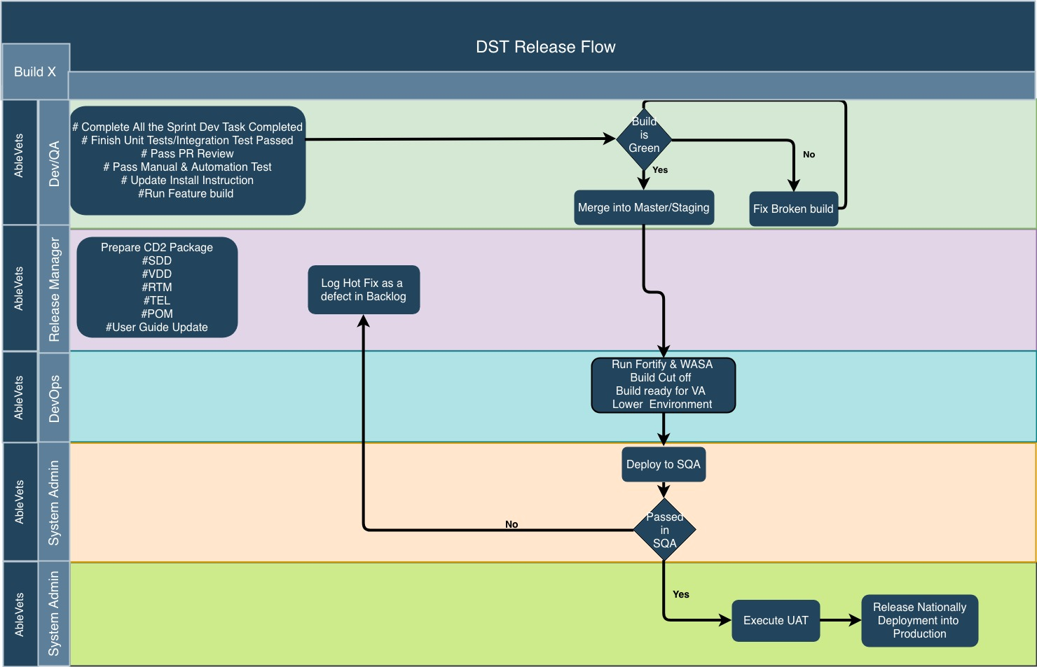

## Timeline

This section providers the project schedule and milestones for this version.

Table 3: DST Task Names and Start Dates

| Task Name | Start Date | End Date |
| --- | --- | --- |
| Hand-off to SQA | 07/17/2019 |  |
| SQA Testing | 07/17/2019 | 07/24/2019 |
| Promote Code to Pre-Prod | 07/17/2019 |  |
| Release to Prod | 07/25/2019 |  |

## Site Readiness Assessment

The DST application will exist within the VA Enterprise Cloud for DEV, PREPROD, DEMO (Sandbox), and Production environments. The DST development team will maintain a local DEV to be used for sprint development and testing processes.

### Deployment Topology (Targeted Architecture)

The figure below shows the Deployment Topology (Targeted Architecture) of the DST application.

Figure 2: Deployment Topology (Targeted Architecture)

This figure shows the Deployment Topology (Targeted Architecture) of the DST application. All environments will maintain parity in order to reduce maintenance and development issues, at the same time providing foundations for a full-scale CI/CD environment. 

### Site Information (Locations, Deployment Recipients)

The initial deployment of the DST web interface will be to IOC sites so that users can verify the functionalities of DST. Once testing is completed and DST is approved for national release, DST will be deployed nationally.

DST will be deployed to the following IOC sites.

* Madison, WI
* Kansas City, MO

## Resources

This section describes hardware, software, facilities, documentation, and any other resources, other than personnel, required for deployment and installation.

### Hardware

DST is in the VAEC cloud enclave. There are four cloud environments maintained. All environments have a common hardware parity with the hardware specifications listed below. All application software and microservice configuration (Kubernetes) are executed on the hardware.

Please refer to Table 2 in the Roles and Responsibilities section of this document for details about who is responsible for preparing the site to meet these hardware specifications.

Figure 3: Hardware Resources

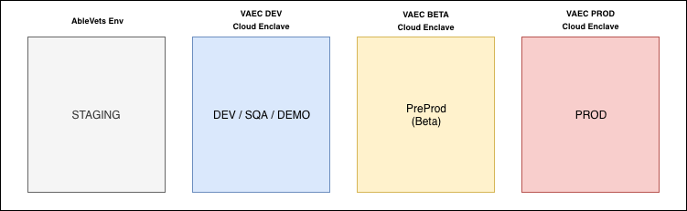

Table 4: Hardware Specifications

|  |  |  |  |  |  |
| --- | --- | --- | --- | --- | --- |
| Required Hardware | Model | Version | Configuration | Manufacturer | Other |
| AWS | M5 | Large | Virtual | Virtual | All Servers |

|  |  |  |
| --- | --- | --- |
| Technology Component  Production 1 | Location | Usage |
| DST Production – VA Cloud | VA Cloud environment | To serve the DST application within the VA Production environment. |

|  |  |  |
| --- | --- | --- |
| Technology Component  Verification/Test | Location | Usage |
| DST PreProd – VA Cloud | VA Cloud environment | To test the DST application within a VA test and/or verification environment. |

|  |  |  |
| --- | --- | --- |
| Technology Component  Verification/Test | Location | Usage |
| DST DEV/SQA/DEMO – VA Cloud | VA Cloud environment | To test the DST application within a VA test and/or verification environment. |

| Technology Component  Development | Location | Usage |
| --- | --- | --- |
| DST Development – AbleVets Cloud | Ablevets Cloud environment | To develop, test, and demo the DST application before transition to the VA cloud environment. |

### Software

The following table describes software specifications required prior to deployment. If there are difference depending upon site, those difference will need to be provided.

Table 5: Software Specifications

|  |  |  |
| --- | --- | --- |
| Required Software | Make | Version |
| Apache | Apache Software | 2.4.X |
| Kubernetes | Red Hat | 1.13.X |
| Docker | Docker, Inc | 18.06.0-ce |
| Red Hat | Enterprise Linux Server | 7.X |

Please refer to Table 2 in the Roles and Responsibilities section of this document for details about who is responsible for preparing the site to meet these software specifications.

### Communications

Notification of scheduled maintenance periods that require the service to be offline or that may degrade system performance will be disseminated to the business user community a minimum of 48 hours prior to the scheduled event.

Notification to VA users for unscheduled system outages or other events that impact the response time will be distributed within 30 minutes of the occurrence.

Notification to VA users for unexpected system outages or other events that impact the response time will be distributed to Users as soon as possible.

Notification will be distributed to VA users regarding technical help desk support for obtaining assistance with receiving and processing.

## Deployment/Installation/Back-Out Checklist

The table below outlines the coordination effort and documents for the day/time/individual when each activity (deploy, install, back-out) is completed for DST.

Table 6: Deployment/Installation/Back-Out Checklist

| Activity | Day | Time | Individual who completed task |
| --- | --- | --- | --- |
| Deploy | Dependent on current build timeline | After 8pm | AbleVets |
| Install | Dependent on current build timeline | After 8pm | AbleVets |
| Back-Out | Dependent on current build timeline | After 8pm | AbleVets |

# Installation

## Platform Installation and Preparation in Facility level

DST requires the following three separate components to be deployed into Production for each facility level.

### Consult Toolbox 1.9.0044

Consult Toolbox (CTB) 1.9.0044 is the AutoHotkey component of the DST solution that is installed as a thick-client on the CPRS user’s workstations by the VA-ITOPS team. It is responsible for monitoring the state of which CPRS screen is displayed to the User, presenting the user with the option to launch DST, and facilitating the transfer of information between CPRS and the DST API/Database. Starting with the deployment of CTB 1.9.0004 included a dedicated DST .ini file that includes a string parameter containing the root URL for the DST endpoints. When this parameter is NULL or the DST .ini file is not found, Consult Toolbox does not attempt any communication with DST and operates based on its pre-DST user experience. The initial national deployment of CTB 1.9.0044 will be deployed with the DST URL set to an empty string.

During Quality Assurance and User Acceptance testing, CTB 1.9.0044 should be tested in configurations with and without the ini file, with and without the DST URL parameter, to insure proper operation in all modes of operation. Multiple test DST URLs will be provided to allow comprehensive testing of error states, edge cases, and all possible DST use cases. These changes have all been tested in DEV, SQA, UAT, and IOC testing events.

### VistA DST Patch to the GMRC Package at Each VistA Site

DST VistA Patch GMRC*3.0*140 is the VistA component of DST which must be installed on every VistA system whose CPRS users need to use DST. The patch includes a protocol that invokes a process to retrieve the consult factor text from DST and insert it into a consult comment whenever a consult is signed that contains the string “DST ID:” in the Reason for Request field. Until DST becomes operational in production, the only way that the DST process would be invoked would be if someone manually added the “DST ID:” string to a consult. If this occurs prior to the deployment of the DST endpoint, the VistA process will receive an HTTP error and will add a consult comment with text indicating that the DST Service was not available (useful for testing, but not disruptive to normal operation). The Patch will essentially lie dormant until the first UAT/IOC testing in Production starts when actual DST ID Global Unique Identifier (GUIDs) are first written to consult orders.

If the DST URL is not active during SQA testing, a test endpoint will be created to allow for end-to-end testing of the DST patch operation. Detect “DST ID:”, retrieve consult factor text from DST API, and insert the consult factor text into a newly created comment.

### DST Application

Within the current CPRS order consult workflow, Veterans and care providers will utilize the DST system to support the decision and election for consult services for a given consult. The DST system will be integrated within the CPRS workflow to support all stakeholders. The DST web application is launched by the CTB application during the order consult workflow.

The DST web application displays all required decision data from the internal Department of Veterans Affairs (VA) data interfaces - Corporate Data Warehouse (CDW), Eligibility and Enrollment (E&E) Service, Provider Profile Management System (PPMS), Standardized Episodes of Care (SEOC), and Master Veteran Index (MVI), data entry functionality to capture a decision, and supportive data interfaces to save a decision to Veterans Health Information Systems and Technology Architecture (VistA) and Computerized Patient Record System (CPRS).

## Download and Extract Files

DST does not download and extract files as a manual process. DST builds all environments using CI/CD pipeline approach utilizing a Jenkins build machine. With use of the Kubernetes infrastructure, as described in later sections, all services that comprise the DST application are compiled, packaged, published in the DST Jenkins environment. When a new deployment is available for an environment, the published Docker image artifacts are pulled from the registry to be installed within Kubernetes environment.

## Database ETL Jobs

The DST application relies on CDW data to provide clinical information and average wait time for services on the application. This information is loaded daily as part of CDW ETL jobs maintained by the DST project team. This ETL code is maintained in the VA GitHub dst-cdw-etl repo and executed on a shared CDW ETL server maintained by the VA CDW group.

Table 7: CDW ETL Jobs

|  |  |  |
| --- | --- | --- |
| Job Name | Schedule | Purpose |
| Consult_to_Clinical_Service | Every day at 2am | Refreshes consult name to clinical service based on clinical stop codes |
| Average_Wait_Time | Every day at 2am | Refreshes facility average wait time based on clinical stop codes |

Figure 6: CDW ETL Jobs

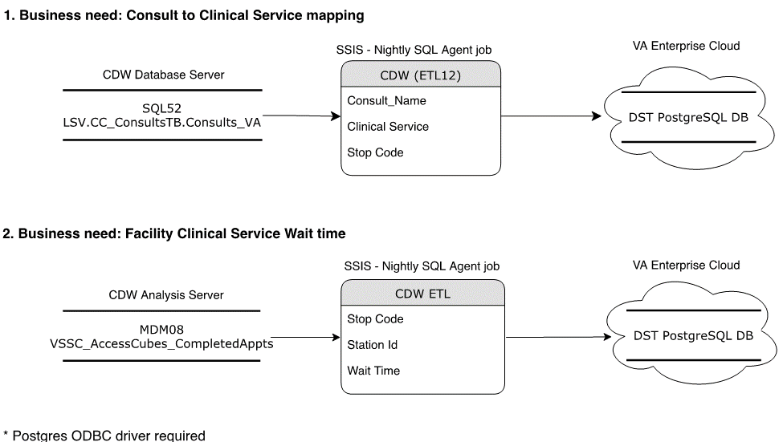

## Installation Scripts

No installation scripts are required after the first installation.

## Cron Scripts

DST executed scheduled jobs within the Kubernetes ecosystem to load SEOC, and purged DST records. These jobs are part of the dst-scheduler VA Git repo. This code repo is built as Kubernetes container as part of the rest of the DST containers.

Table 8: Cron Scripts

| Job Name | Schedule | Purpose |
| --- | --- | --- |
| Delete_Decision_Support | Every day at 2am | Purges stale DST records that are greater than 30 days old, since DST is the source of record for this data |
| Load_SEOC | Every day at 2am | Refreshes active SEOC data within DST system |

## Access Requirements and Skills Needed for the Installation

Installers will need to have a proper ePAS in order to gain access to the server with elevated privileges. The installers will need to have knowledge of Apache, Kubernetes, Docker and GIT.

## Installation Procedure

The DST application uses Helm commands to install the DST Helm chart. This chart describes the DST Kubernetes microservices and configuration for the system. Helm and Kubernetes are maintained in each DST VA Git repo. Specifically, the DST main chart that maintains the complete DST ecosystem is within the dst-cprw-web VA Git repo under /chars/dst-cprs-web/Chart.yaml.

To upgrade DST microservices with a new version of the software on any DST node that has Helm installed, execute the following commands:

1. helm repo update #get all latest charts
2. helm upgrade <chart name> --namespace <DST namespace> --version=<version to be upgrade to>
3. helm list #to verify latest charts that are installed

## Installation Verification Procedure

To verify the installation is running on any DST node that has Helm installed, execute the following commands:

1. helm list #to verify latest charts that are installed

## System Configuration

This section is not applicable to the DST project.

## Database Tuning

The database tuning was performed during the initial installation. No additional tuning is required for this installation.

# Back-Out Procedure

The steps described below outline the procedure to remove the DST application from the CPRS Platform in Production.

## Back-Out Procedure

On any DST node that has Helm installed, execute the following commands:

1. helm list #to verify latest charts that are installed
2. helm rollback <chart name> --version <version to be rolled back>

## Authority for Back-Out

Based on authority provided by our Business Sponsor and VA OIT IT program manager, DST can be backed out in accordance to their approval.

DST can back-out any service within the Kubernetes cluster, which are all application components.

# Rollback Procedure

Database (DB) snapshots are taken every evening. To restore the DST Database instance from a DB snapshot

1. Sign in to the AWS Management Console and open the Amazon RDS console
2. In the navigation pane, choose Snapshots.
3. Choose the DB snapshot that you want to restore from.
4. For Actions, choose Restore Snapshot.

The Restore DB Instance page appears.

1. For DB Instance Identifier under Settings, enter the name that you want to use for the restored Database instance. If you are restoring from a DB instance that you deleted after you made the Database snapshot, you can use the name of that DB instance.
2. Choose Restore DB Instance.

## Rollback Considerations.

DST can roll back the DST AWS RDS Postgres instance.

## Rollback Criteria

Rollback criteria are not applicable.

## Rollback Risks

There is minimal risk associated to these rollback procedures. It is common practice to rollback Kubernetes microservice and is part of the design of the technology. All DST application code and infrastructure are maintained as code that is saved in source control in VA GitHub So, there is minimal potential loss of functionality when an issue arises. Finally, AWS provides highly resilient backup processes for all AWS RDS databases.

## Authority for Rollback

Based on authority provided by our Business Sponsor and VA OIT IT program manager, DST can be backed out in accordance to their approval.

## Rollback Procedure

The rollback procedure steps are documented in Section 6.

# Risk and Mitigation Plan

The DST project team maintains a Program Risk Registry. Refer to the Program Risk Registry for all risks and mitigation plans for the entire DST project, including Consult Toolbox and VistA integration along with the rest of the VA partner interfaces (MVI, E&E, PPMS, CDW, SEOC).